Live chat
The Live Chat feature lets an authenticated One Bangkok user open a real‑time chat with a support agent. The UI is rendered by ConnectX's React Native SDK. The chat itself (history, transport, attachments, theming) is owned by ConnectX once LiveChat.show() is called.

User Flow
- User taps the Live Chat tab in the bottom navigation.
- openLiveChat() checks firebaseConfigState.enable_live_chat. If off, no‑op (the tab is also hidden when off, so this is defence‑in‑depth).
- If there is no auth token, the user is sent to WelcomePageScreen to sign in. (There is no automatic return‑to‑chat after login — the user must re‑tap the tab.)
- App shows a loading state and calls accountService.syncConnectX() (POST /me/account/sync/connect_x).
- On success, the JWT sub claim is decoded as the accountId.
- LiveChat.show() mounts the ConnectX chat UI with the OB custom header.
- While the chat is mounted, appSettingState.isLiveChatOpen is true.
- Tapping the back button calls LiveChat.hide(); the cleanup effect flips isLiveChatOpen back to false.

Flowchart
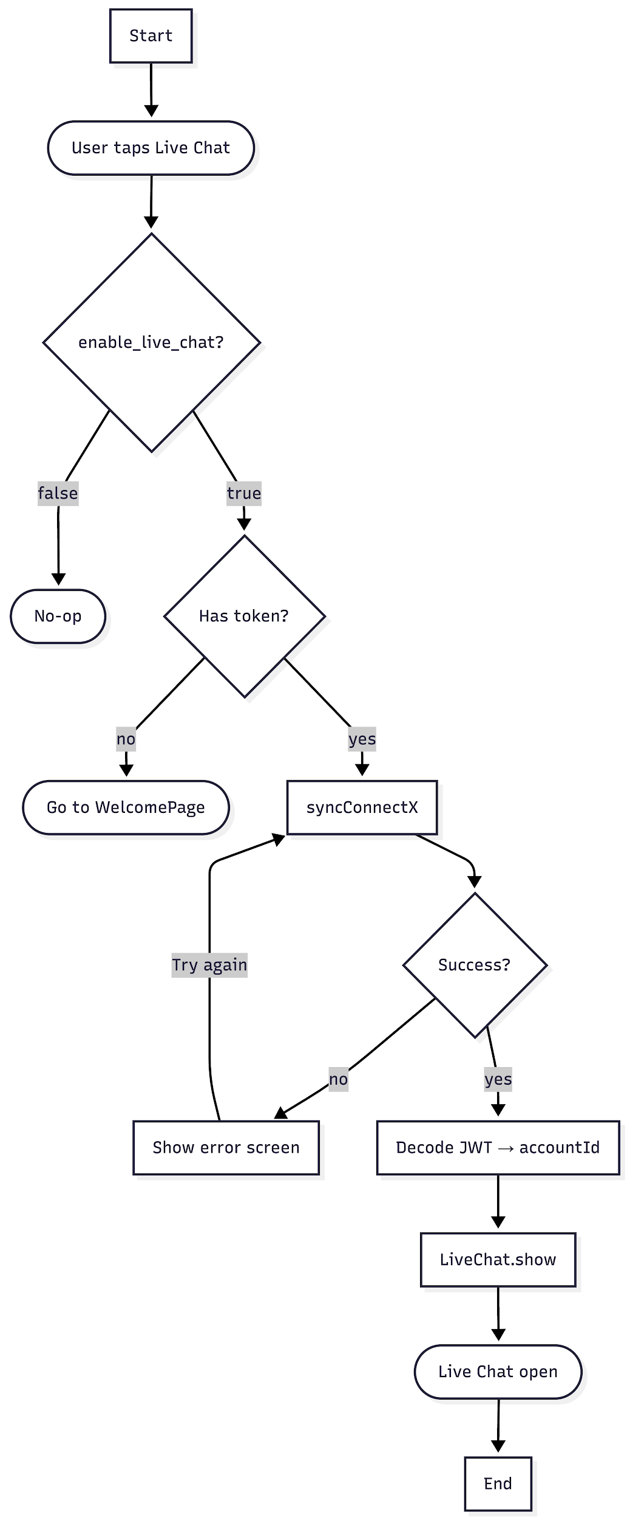

Sequence Diagram
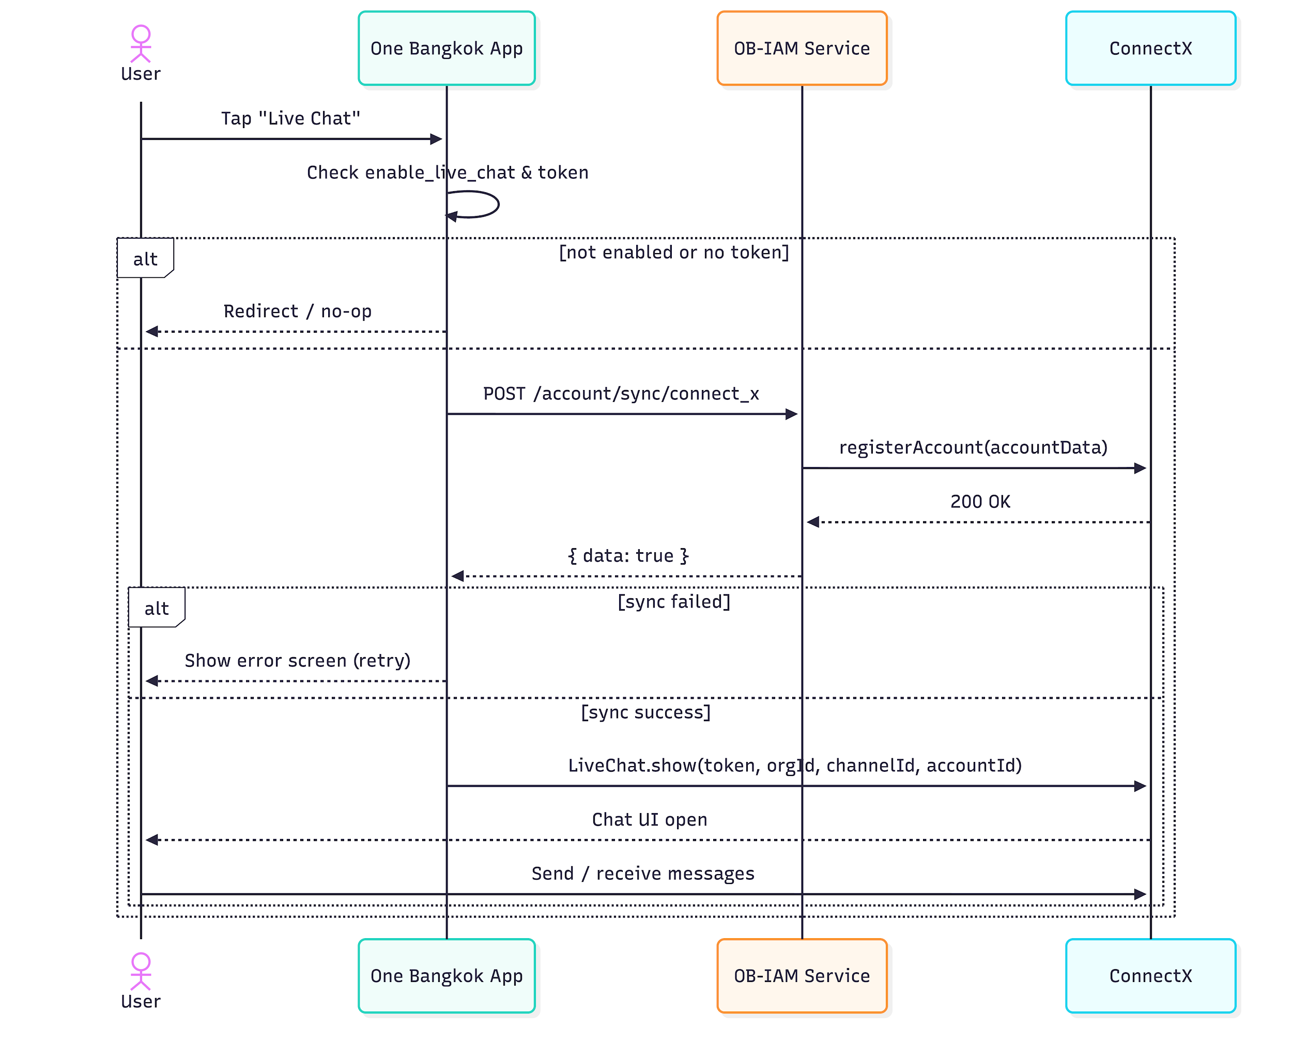

Sync account Connect X

Overview
- Method: POST
- Path: /me/account/sync/connect_x
- OperationId: account.syncConnectXAccount
- Description: Syncs the authenticated OB account into ConnectX so the user can be identified in the Live Chat session. Called every time the user opens Live Chat.

Request

Header Parameter
Name | Type | Required | Description
Authorization | string | true | Bearer token from OB IAM session
x-account-id | string | false | Override account ID

Request Example
POST /me/account/sync/connect_x
Authorization: Bearer eyJhbGci...

Success Response

HTTP 200
Field | Type | Description
data | object or null | Non-null object indicates sync success; `null` indicates failure.

Success Example
{
"data": true
}

Environment variables (app/OneBangkok/.env.*)
Var | Used by | Notes
CONNECTX_TOKEN | ConnectXMobileSdk.initialize | Tracking / analytics SDK token.
CONNECTX_ORGANIZATION_ID | ConnectXMobileSdk.initialize | Tracking org id.
CONNECT_X_LIVE_CHAT_TOKEN | LiveChat.show | Live chat session token.
CONNECT_X_LIVE_CHAT_ORG_ID | LiveChat.show | Live chat org id.
CONNECT_X_LIVE_CHAT_CHANNEL_ID | LiveChat.show | Live chat channel id (varies per env).

Feature flag
enable_live_chat: Firebase Remote Config boolean.

- Default: false (remote_config_defaults.tsx:88).
- Read via Hookstate at src/states/firebase.tsx:100.
- Guards: the bottom tab render, openLiveChat(), and LiveChatProvider.

